CSE221
Lab Assignment 03
Summer 2023

Submission Guidelines:

- You can code all of them either in Python, CPP, or Java. But you should choose a specific language for all tasks.
- For each task write separate python files like task1.py, task2.py, and so on.
- For each problem, take input from files called "inputX.txt" and output at "outputX.txt", where X is the task number.
- Add a hand written explanation of 3-4 lines for each of your solutions in a separate document. You may compile all of your explanations in a single file.
- Finally zip all the files and rename this zip file as per this format: LabSectionNo_ID_CSE221LabAssignmentNo_Summer2023.zip [Example: LabSection01_21101XXX_CSE221LabAssignment03_Summer2023.zip]
- Don't copy from your friends.
- You MUST follow all the guidelines, naming/file/zipping convention stated above.
Failure to follow instructions will result in a straight 50%-mark deduction.

Task 01 [15 Points]:

Somewhere in the universe, the Biannual Regional Alien Competition is taking place.
There are N aliens standing in a line. You will be given a permutation of N, which denotes the height of each alien. A sequence of N numbers is called a permutation if it contains all integers from 1 to N exactly once. For example, the sequences [3,1,4,2], [1] and [2,1] are permutations, but [1,2,1], [0,1] and [1,3,4] — are not.
In the competition, for each alien, the judge wants to count how many aliens are standing on its right side with a strictly smaller height. Then the judge wants to add up all the counts. To do this, the judge writes the following piece of code.

count = 0
for i in range(n):
for j in range(i+1, n):
if H[i] > H[j]:
count+=1
However, their algorithm wasn’t efficient at all. Hence, the alien calls you to write a better solution for the program.
More formally, you have to count how many pairs of aliens are standing in the line such that H[i] > H[j] and i < j. Here, A is a permutation of the aliens’ heights. And i, j denote the Aliens’ positions.
Input
The first line contains a single integer 1 <= N <= 10⁶ - the number of total aliens.
The next line contains N integers H₁,H₂,…………,H_{n}(1 ≤ H_{i} ≤ N)- the height of the i^{th} alien. It is guaranteed that the given heights will be a permutation of N.
Output

Print a single integer, which denotes the total number of pairs (i, j) such that i < j and H_{i} > H_{j.}

Sample Input/Output:

Sample Input 1 | Sample Output 1
5  1 2 3 4 5 | 0
Sample Input 2 | Sample Output 2
5  5 4 3 2 1 | 10
Sample Input 3 | Sample Output 3
8  2 7 4 1 5 6 8 3 | 11

Sample Input 3 Explanation:

In the sample input 3, the following pairs on alien’s heights satisfy the condition: (2,1), (7,4), (7,1), (7,5), (7,6), (7,3), (4,1), (4,3), (5,3), (6,3), (8,3)

Task 02 [15 points]:

You are given a list A of N integers. You have to choose two indices i and j such that 1 <= i < j <= N and A[i] + A[j]² is maximum possible. Here, we are considering 1-based indexing.

Write a code which will find the maximum value of A[i] + A[j]² in O(N) or O(N log N).

Input
The first line contains a single integer 1 <= N <= 10⁶ - the length of the list.
The next line contains N integers A₁,A₂,…………,A_{n} (-10⁸ ≤ A_{i} ≤ 10⁸) separated by a space.
Output
Print a single integer - which denotes the maximum possible value of A[i] + A[j]².
Sample Input/Output:

Sample Input 1 | Sample Output 1
5  9 6 5 8 2 | 73
Sample Input 2 | Sample Output 2
8  5 10 4 -3 1 6 -10 2 | 110
Sample Input 3 | Sample Output 3
7  -5 -2 -6 -7 -1 8 2 | 63

Task 03 [10 Points]:

In this problem, you will be given a list of numbers. You have to sort the list using the Quick Sort algorithm in ascending order.

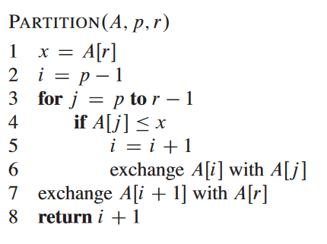
Pseudocode of Quick Sort Algorithm:

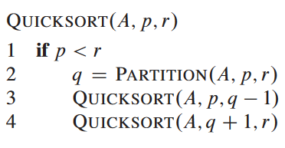

[The code snippet has been taken from the book: Introduction to Algorithms]

Input

The first line contains an integer N (1 <= N <= 10⁵), denoting the length of Alice’s list. In the next line, there will be N integers separated by space.

Output:

You have to sort the number using the Quick Sort algorithm in ascending order and show the sorted list.

Sample Input/Output:

Sample Input 1 | Sample Output 1
8  9 5 4 6 1 3 2 9 | 1 2 3 4 5 6 9 9
Sample Input 2 | Sample Output 2
1  10 | 10
Sample Input 3 | Sample Output 3
6  8 1 4 2 1 3 | 1 1 2 3 4 8
Sample Input 4 | Sample Output 4
7  7 6 5 4 3 2 1 | 1 2 3 4 5 6 7

Task 04 [10 Points]:

In this problem, you will be given a list of numbers. You have to find the k-th smallest value from the list without sorting using the Partition function of Quick sort.

We will consider the 1-based indexing of the list.

Input

The first line contains an integer N (1 <= N <= 10⁶), denoting the length of the list.

The next line contains N integers A₁,A₂,…………,A_{n} (1 ≤ A_{i} ≤ 10⁶) separated by a space.

The third line contains a single integer Q (1 <= Q <= 100) - which denotes the number of queries you have to answer.

Each of the next Q lines will contain a single integer K (1 ≤ K ≤ N).

Output:

For each query, you have to find the K-th smallest number from the given list.

Sample Input/Output:

Sample Input 1 | Sample Output 1
9 // Total Elements  10 11 10 6 7 9 8 15 2  4 // Total queries  5  3  2  7 | 9  7  6  10

